Red Wax Puck Process

The following pages are instructions for creating red wax pucks from red wax cylinders purchased by Team Solutions Dental.

Part 1 – Cutting Consistent Sized Pucks

Our pucks are to be 20mm +/- 0.8mm. If beyond these boundaries, one should consider rejecting the puck in order to maintain proper function of our machines.

Below is the puck saw. Be wary of the belt and the blade.

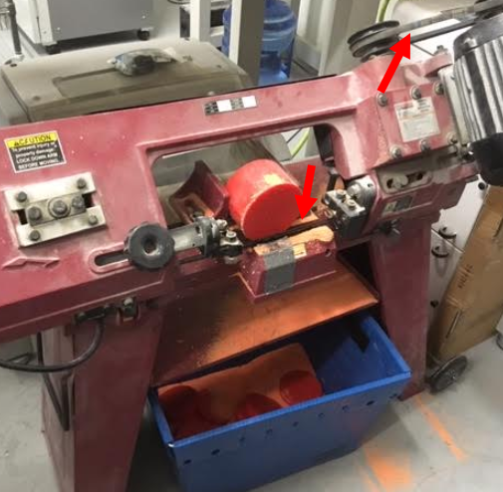

You will need calipers (preferably with a locking mechanism).

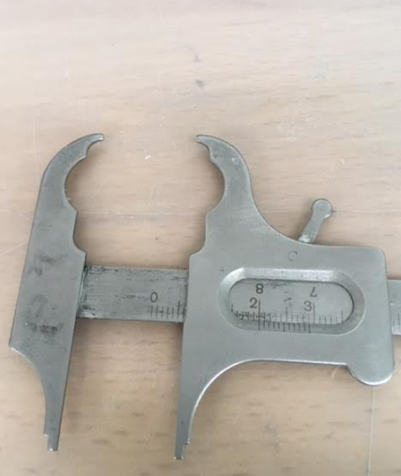

Set it to 20mm and lock it if possible. You will use these to mark the cutting line on the wax cylinder.

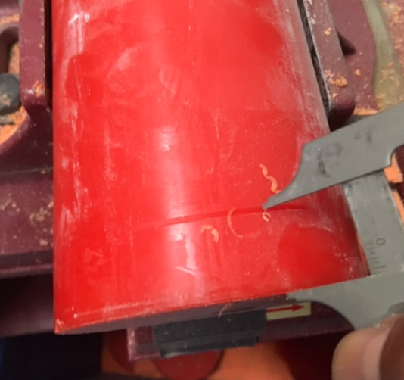

Use the line marked onto the puck in conjunction with the tape line on the saw to cut your 20mm puck.

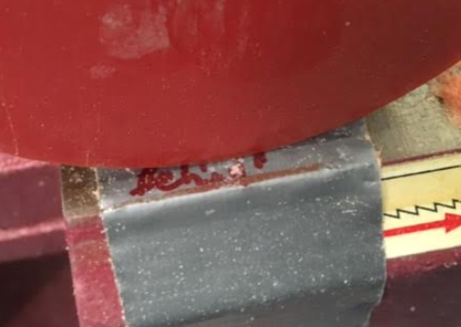

Then swing the blade down into position on the waste side of your line.

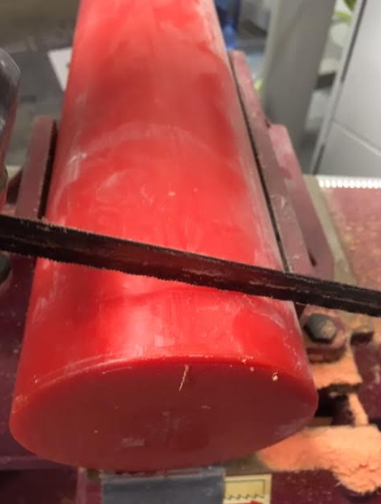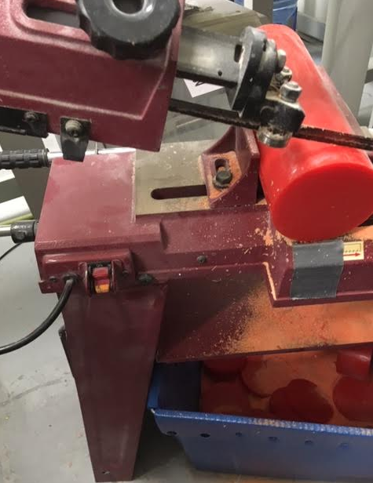

Measure your puck to be sure you are within tolerance.

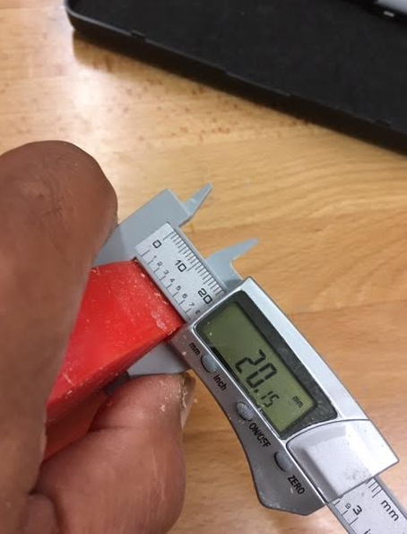

Part 2

Creating the Puck Channel

Now it’s time to cut our puck edges to create the 10mm center channel around the circumference of the puck.

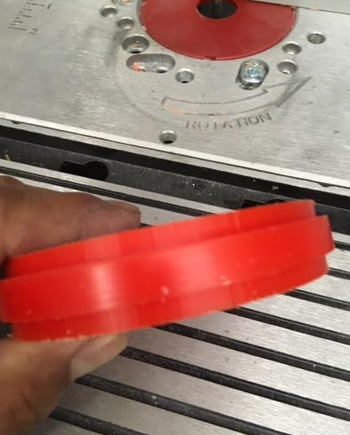

Set up with your previously cut pucks, a puck guide, and routing table with vac.

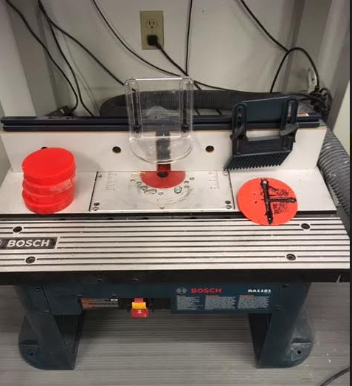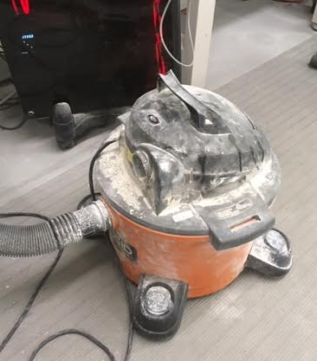

You may need to be creative to attach the vac to the routing table. Remember that there has been duct tape used on every great invention since the dawn of man.

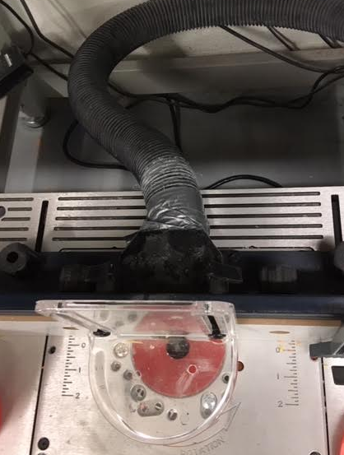

We will use the red puck line guide as a cutting guide under the safety while cutting.

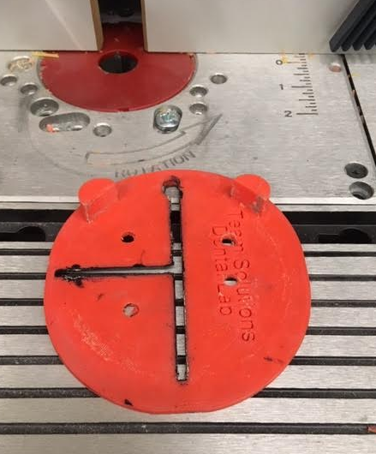

The puck sits against the edges and when turned upside down (guide on top), it will allow a 2mm cut off of the edge of the puck while you rotate it manually.

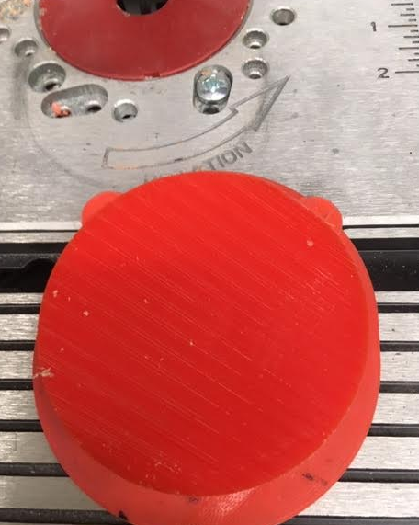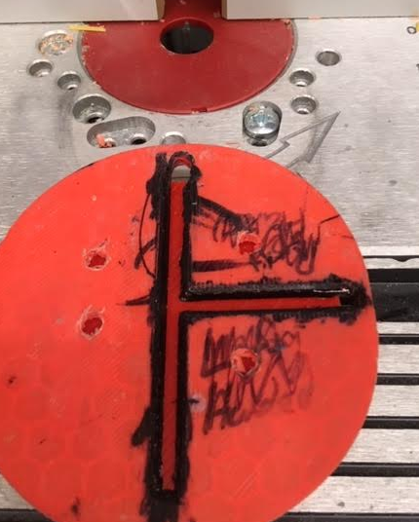

The puck and guide must be pressed up against the block so that the router will cut the puck. \*\*\*\*\*\*\*\*\*\*\*\*Danger! Do NOT let your fingers go near the router blade!\*\*\*\*\*\*\*\*\*

Turn the puck counter clockwise while holding the guide stationary. Hands on training may be required prior to doing this safely.

